|  |  |
| --- | --- |
| **Name** |  |
| **Module** | Maths for IT |
| **Ref** | 5N18396 |
| **Assessment** | Assignment 2 |
| **Date** | 23 April 2020 |

# Part 1: Boolean Logic and Boolean Algebra (10%)

(B’+D)+(CB)(B’+D’)(AD’)’

(B’+D)+(CB)(B’+D’)A’D’’

(B’+D)+(CB)(B’+D’)A’D

WE CHANGE EVERY THINGS OPPOSITE WAY

A’D(B’+D)+CB(B’+D’)

Distributive Law

A’DB’+DD+CB(B’+D’)

RULE -7

A’DB’+D+CB(B’+D’)

A’DB+D+CBB’+D’

RULE -8

A’BD+D+C0+D’

A’BD+D+C+D’

RULE-6

A’BD+1+C

RULE-2

A’BD+1

RULE-2

A’B1

A’B

## a: Circuit labelled at each point

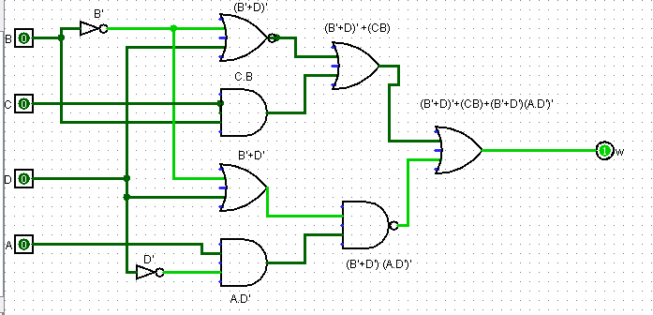

## b, c, d: Truth table with SOP and POS

SOP which has input 1 and we write the var with dash ex A’

|  |  |  |
| --- | --- | --- |
| A B C D | Output | POS / SOP |
| 0 0 0 0 | 1 | A’ B’ C’ D’ |
| 0 0 0 1 | 0 | (A+B+C+D’) |
| 0 0 1 0 | 1 | A’ B’ C D’ |
| 0 0 1 1 | 1 | A’ B’ C D |
| 0 1 0 0 | 0 | (A +B’+C+D) |
| 0 1 0 1 | 0 | (A+B’+C+D’) |
| 0 1 1 0 | 1 | A’ B C D |
| 0 1 1 1 | 1 | A’ B C D |
| 1 0 0 0 | 1 | A B’ C’ D’ |
| 1 0 0 1 | 1 | A B’ C’ D |
| 1 0 1 0 | 1 | A B’ C D’ |
| 1 0 1 1 | 1 | A B’ C D |
| 1 1 0 0 | 1 | A B C’ D’ |
| 1 1 0 1 | 1 | A B C’ D |
| 1 1 1 0 | 1 | A B C D’ |
| 1 1 1 1 | 1 | ABCD |

Explain how the SOP and POS are created

## e: Minimise the expression output from the circuit in a

Apply one rule at each step to demonstrate logical progression of thought.

|  |  |
| --- | --- |
| **Expression** | **Rule applied** |
|  |  |
|  |  |
|  |  |
|  |  |
|  |  |
|  |  |
|  |  |

## f: Application of methods

Karnaugh Map

W=Z=Z(1,3,4,7,8,9,10,11,12,13,14,15,16)

|  |  |  |  |  |  |
| --- | --- | --- | --- | --- | --- |
| C D |  | A B | | | |
|  | 0 0 | 0 1 | 1 1 | 1 0 |
| 0 0 |  | 1 | 1 | 1 |
| 0 1 | 1 |  | 1 | 1 |
| 1 1 |  |  | 1 | 1 |
| 1 0 | 1 | 1 | 1 | 1 |
|  |  |  |  |  |  |

W=A’+B’+C’

## g: Create Minimized circuit

table compare)

# Part 2: Algorithms (20%)

## a: Definitions

1. Algorithm
2. Divide and Conquer
3. Recursion
4. Significance of ii and iii in a Binary Search algorithm

## b: Flowcharts

## c, d, e: Link to file folder with functions

All files:

* have headers
* Include complete docstings and doctests
* Are PEP8 compliant

Link here: